**ACKNOWLEDGEMENT**

I would like to express my deepest appreciation to all those who provided me the possibility to complete this report.  A special gratitude I give to our project  mentor, Mr Sunil kumar yadav, whose contribution in stimulating suggestions and encouragement,  helped me to coordinate my project, who gave me the golden opportunity to do this wonderful project on the topic (Write the topic name), which also helped me in doing a lot of Research and I came to know about so many new things I am really thankful to them.Secondly I would also like to thank my friends who helped me a lot in finalizing this project within the limited time frame. I have to appreciate the guidance given by other supervisor as well as the panels especially in our project presentation that has improved our presentation skills thanks to their comment and advices.

**TABLE OF CONTENTS**

**ABSTRACT**

We view information sharing as a promising target of research. Technology and human practice have been evolving toward more opportunities and varied manners in which information can be shared. We propose that 'information sharing' is best understood as a continuum, that concomitantly reflects behavioural, social, economic, legal, and technological influences. "Information" is a hybrid of both "public" and "private" goods. The mechanisms that enable, predict and catalyze sharing behaviour in online contexts should be of major interest to both scholars and practitioners of knowledge systems. We cite a spectrum of analytical as well as empirical research into the topic of sharing, identifying the methods and theories used in the approaches to date. We also review the major online technology genres of import for sharing. We suggest an initial map of constructs to chart future research on sharing.

**INTRODUCTION:**

The project is a web based application where a user can register himself/herself and can connect to other persons based upon the location or area. In this a user can able to login by their user ID’s and password, they can share the files , information ,views to other peoples through this application. It consists of several modules in which 1st module cosists of user login and user registration.

**MODULES:**

* User Registration
* User Login
* Profile
* Edit Profile
* Change Password
* Search People
* Talk People
* Forget Password

**SOFTWARE REQUIREMENTS:**

* Windows 10
* My SQL workbench
* Apache tomcat server or Glassfish 5.0 server

**TECHNOLOGIES USED:**

* Java SE
* Java EE
* HTML/CSS/Xml/Bootstrap
* Servlet/JSP
* JDBC
* My SQL
* JQuery
* JavaScript

**JAVA SE:**

When most of the people think of java programming language, they think of java SE API. Java’s API provides the core functionality of the java programming language. It defines everything from the basic types and objects of java programming language to high level classes that are used for networking, Security, Database acess, Graphical User Interface (GUI) development, and XML parsing.

In addition to the core API, java SE platform consists of a Virtual machine, development tools, deployment technologies, and other class libraries and toolkit commonly used in java technology applications.

**JAVA EE:**

The Java EE platform is built on top of the Java SE platform . The java EE platform provides an API and runtime environment for developing and running large scale, multi-tiered, scalable, reliable, and secure network applications.

Java EE is defined by its [specification](https://en.wikipedia.org/wiki/Program_specification). The specification defines [API](https://en.wikipedia.org/wiki/Application_programming_interface)s (application programming interface) and their interactions. As with other [Java Community Process](https://en.wikipedia.org/wiki/Java_Community_Process) specifications, providers must meet certain conformance requirements in order to declare their products as Java EE compliant.

Java EE was maintained by [Oracle](https://en.wikipedia.org/wiki/Oracle_Corporation) under the [Java Community Process](https://en.wikipedia.org/wiki/Java_Community_Process). On September 12, 2017, [Oracle Corporation](https://en.wikipedia.org/wiki/Oracle_Corporation) announced that it would submit Java EE to the [Eclipse Foundation](https://en.wikipedia.org/wiki/Eclipse_Foundation).The Eclipse top-level project has been named Eclipse Enterprise for Java (EE4J). The Eclipse Foundation was forced to change the name of Java EE because Oracle owns the trademark for the name "Java."[[9]](https://en.wikipedia.org/wiki/Java_Platform,_Enterprise_Edition#cite_note-9) On February 26, 2018, it was announced that the new name of Java EE will be Jakarta EE.

**HTML:**

Hypertext Markup Language (HTML) is the standard [markup language](https://en.wikipedia.org/wiki/Markup_language) for documents designed to be displayed in a [web browser](https://en.wikipedia.org/wiki/Web_browser). It can be assisted by technologies such as [Cascading Style Sheets](https://en.wikipedia.org/wiki/Cascading_Style_Sheets) (CSS) and [scripting languages](https://en.wikipedia.org/wiki/Scripting_language) such as [JavaScript](https://en.wikipedia.org/wiki/JavaScript).

[HTML elements](https://en.wikipedia.org/wiki/HTML_element) are the building blocks of HTML pages. With HTML constructs, [images](https://en.wikipedia.org/wiki/HTML_element#Images_and_objects) and other objects such as [interactive forms](https://en.wikipedia.org/wiki/Fieldset) may be embedded into the rendered page. HTML provides a means to create [structured documents](https://en.wikipedia.org/wiki/Structured_document) by denoting structural [semantics](https://en.wikipedia.org/wiki/Semantics) for text such as headings, paragraphs, lists, [links](https://en.wikipedia.org/wiki/Hyperlink), quotes and other items. HTML elements are delineated by tags, written using [angle brackets](https://en.wikipedia.org/wiki/Bracket#Angle_brackets). Tags such as <img /> and <input /> directly introduce content into the page. Other tags such as <p> surround and provide information about document text and may include other tags as sub-elements. Browsers do not display the HTML tags, but use them to interpret the content of the page.

**CSS:**

Cascading Style Sheets, fondly referred to as CSS, is a simple design language intended to simplify the process of making web pages presentable.

CSS handles the look and feel part of a web page. Using CSS, you can control the color of the text, the style of fonts, the spacing between paragraphs, how columns are sized and laid out, what background images or colors are used, layout designs ,variations in display for different devices and screen sizes as well as a variety of other effects.

CSS is easy to learn and understand but it provides powerful control over the presentation of an HTML document. Most commonly, CSS is combined with the markup languages HTML or XHTML.

**BOOTSTRAP:**

Bootstrap is a web framework that focuses on simplifying the development of informative web pages (as opposed to [web apps](https://en.wikipedia.org/wiki/Web_Apps)). The primary purpose of adding it to a web project is to apply Bootstrap's choices of color, size, font and layout to that project. As such, the primary factor is whether the developers in charge find those choices to their liking. Once added to a project, Bootstrap provides basic style definitions for all [HTML elements](https://en.wikipedia.org/wiki/HTML_element). The result is a uniform appearance for prose, tables and form elements across [web browsers](https://en.wikipedia.org/wiki/Web_browser). In addition, developers can take advantage of CSS classes defined in Bootstrap to further customize the appearance of their contents. For example, Bootstrap has provisioned for light- and dark-colored tables, page headings, more prominent pull quotes, and text with a highlight.

Bootstrap also comes with several JavaScript components in the form of [jQuery](https://en.wikipedia.org/wiki/JQuery) plugins. They provide additional user interface elements such as [dialog boxes](https://en.wikipedia.org/wiki/Dialog_box), [tooltips](https://en.wikipedia.org/wiki/Tooltip), and carousels. Each Bootstrap component consists of an HTML structure, CSS declarations, and in some cases accompanying JavaScript code. They also extend the functionality of some existing interface elements, including for example an auto-complete function for input fields.

**SERVLET:**

Servlets are programs that run on a web server and build web pages on fly. Servlets are loaded and executed by web server. A servlet accesses requests from the client, performs some task, and return results.

* The client makes a request.
* The web server forwards the request to the servlet after receiving it from the client.
* Some kind of process is done by the servlet after receiving the request.
* A response is returned back to the web server from the servlet.
* The web server will forward the response to the client.

**JSP:**

Java Server Pages (JSP) is a server-side programming technology that enables the creation of dynamic, platform-independent method for building Web-based applications. JSP have access to the entire family of Java APIs, including the JDBC API to access enterprise databases.

Architecturally, JSP may be viewed as a high-level [abstraction](https://en.wikipedia.org/wiki/Abstraction_(computer_science)) of [Java servlets](https://en.wikipedia.org/wiki/Java_servlet). JSPs are translated into [servlets](https://en.wikipedia.org/wiki/Java_Servlet) at runtime, therefore JSP is a Servlet, each JSP servlet is cached and re-used until the original JSP is modified.[[2]](https://en.wikipedia.org/wiki/JavaServer_Pages#cite_note-2)

JSP allows Java code and certain predefined actions to be interleaved with static web markup content, such as HTML. The resulting page is compiled and executed on the server to deliver a document. The compiled pages, as well as any dependent Java libraries, contain Java bytecode rather than [machine code](https://en.wikipedia.org/wiki/Machine_code). Like any other .jar or Java program, code must be executed within a [Java virtual machine](https://en.wikipedia.org/wiki/Java_virtual_machine) (JVM) that interacts with the server's host [operating system](https://en.wikipedia.org/wiki/Operating_system) to provide an abstract, platform-neutral environment.

JSPs are usually used to deliver HTML and XML documents, but through the use of OutputStream, they can deliver other types of data as well.

**JDBC:**

**JDBC** stands for J ava D ata b ase C onnectivity, which is a standard Java API for database-independent connectivity between the Java programming language and a wide range of databases. The **JDBC** library includes APIs for each of the tasks mentioned below that are commonly associated with database usage. Making a connection to a database.

There are 5 steps in JDBC are as follows:

1. Load the Driver class.
2. Get the Connection.
3. Create the statements.
4. Execute the SQL queries.
5. Close the connection.

* Example to connect java program with Oracle DB:

import java.sql.*;

import java.io.*;

public class JdbcEx{

public static void main(String[] args){

try{

Class.forName("oracle.jdbc.driver.OracleDriver");

Connection c=DriverManager.getConnection("jdbc:oracle:thin:@localhost:1521:xe",

"userid","pass");

Statement st=c.createStatement();

st.executeUpdate("insert intoempinfo values('e101','Ram kumar',12000,21)");

System.out.println("Success");

c.close();

}catch(Exception ex){

System.out.println(ex);

}

}

}

* Example to connect java program with MySQL DB:

import java.sql.*;

import java.io.*;

public class JdbcEx{

public static void main(String[] args){

try{

Class.forName("com.mysql.jdbc.Driver");

Connection c=DriverManager.getConnection("jdbc:mysql://localhost:3306/MyDB",

"userid","pass");

Statement st=c.createStatement();

st.executeUpdate("insert intoempinfo values('e101','Ram kumar',12000,21)");

System.out.println("Success");

c.close();

}catch(Exception ex){

System.out.println(ex);

}

}

}

**MySQL:**

MySQL is an [open-source](https://en.wikipedia.org/wiki/Open-source_software) [relational database management system](https://en.wikipedia.org/wiki/Relational_database_management_system) (RDBMS).Its name is a combination of "My", the name of co-founder [Michael Widenius](https://en.wikipedia.org/wiki/Michael_Widenius)'s daughter, and "[SQL](https://en.wikipedia.org/wiki/SQL)", the abbreviation for [Structured Query Language](https://en.wikipedia.org/wiki/Structured_Query_Language).

MySQL is [free and open-source software](https://en.wikipedia.org/wiki/Free_and_open-source_software) under the terms of the [GNU General Public License](https://en.wikipedia.org/wiki/GNU_General_Public_License), and is also available under a variety of [proprietary](https://en.wikipedia.org/wiki/Proprietary_software) licenses. MySQL was owned and sponsored by the [Swedish](https://en.wikipedia.org/wiki/Sweden) company [MySQL AB](https://en.wikipedia.org/wiki/MySQL_AB), which was bought by [Sun Microsystems](https://en.wikipedia.org/wiki/Sun_Microsystems) (now [Oracle Corporation](https://en.wikipedia.org/wiki/Oracle_Corporation)).In 2010, when Oracle acquired Sun, Widenius [forked](https://en.wikipedia.org/wiki/Fork_(software_development)) the [open-source](https://en.wikipedia.org/wiki/Open-source) MySQL project to create [MariaDB](https://en.wikipedia.org/wiki/MariaDB).

MySQL is a component of the [LAMP](https://en.wikipedia.org/wiki/LAMP_(software_bundle)) [web application](https://en.wikipedia.org/wiki/Web_application) [software stack](https://en.wikipedia.org/wiki/Software_stack) (and [others](https://en.wikipedia.org/wiki/List_of_AMP_packages)), which is an acronym for [Linux](https://en.wikipedia.org/wiki/Linux), [Apache](https://en.wikipedia.org/wiki/Apache_HTTP_Server), MySQL, [Perl](https://en.wikipedia.org/wiki/Perl)/[PHP](https://en.wikipedia.org/wiki/PHP)/[Python](https://en.wikipedia.org/wiki/Python_(programming_language)). MySQL is used by many database-driven web applications, including [Drupal](https://en.wikipedia.org/wiki/Drupal), [Joomla](https://en.wikipedia.org/wiki/Joomla), [phpBB](https://en.wikipedia.org/wiki/PhpBB), and [WordPress](https://en.wikipedia.org/wiki/WordPress). MySQL is also used by many popular [websites](https://en.wikipedia.org/wiki/Website), including [Facebook](https://en.wikipedia.org/wiki/Facebook), [Flickr](https://en.wikipedia.org/wiki/Flickr), [MediaWiki](https://en.wikipedia.org/wiki/MediaWiki), [Twitter](https://en.wikipedia.org/wiki/Twitter), and [YouTube](https://en.wikipedia.org/wiki/YouTube).

**MODULE 1st: (USER REGISTRATION AND USER LOGIN)**

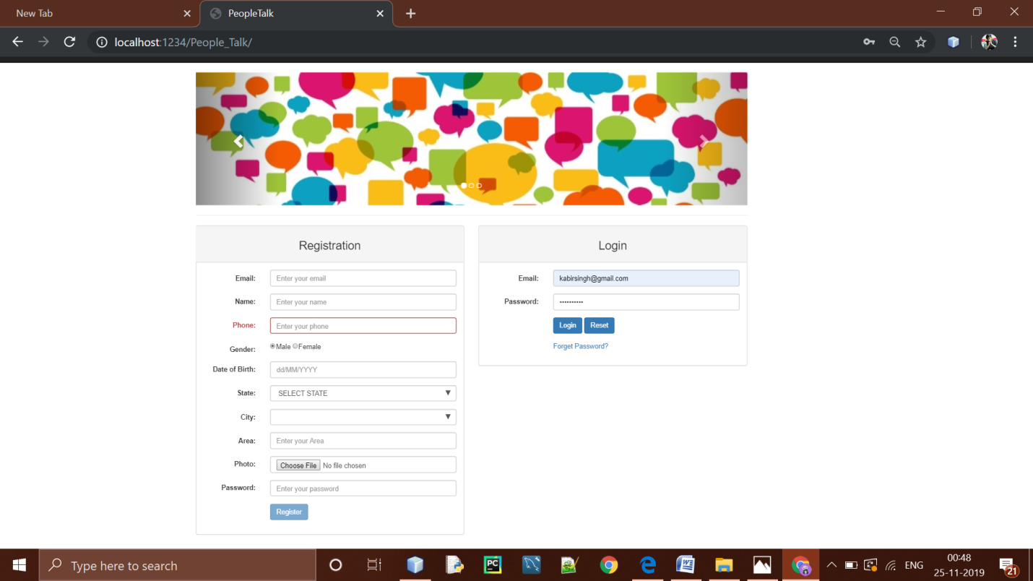

Above is the 1st module which is categorized into two parts one is registration and another is login, In registration part, one could register himself/herself just by filling their details, all details are mandatory where as area and photo block is optional.

In the second part which is the Login, in this a user can login just by entering their registered mail ID and valid password .

And if a user forgets their password then they can recover their password just by clicking on the forget password.

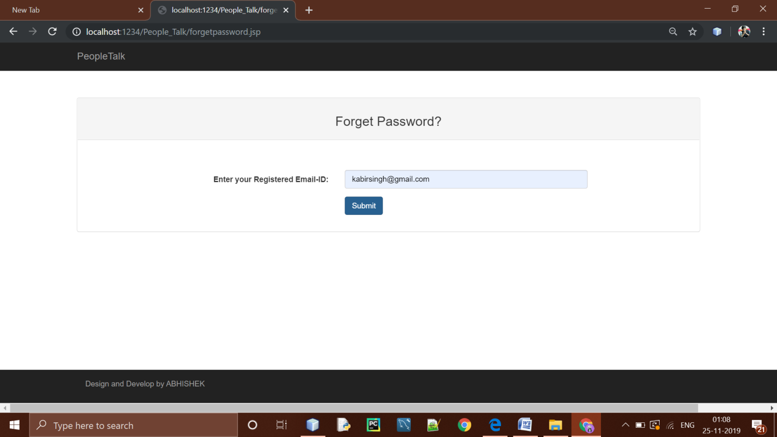

If a user forgets his/her password then he/she can click on forgot password in order to get the password, In forgot password block user have to enter their registered email ID and then have to click on submit button after that the password will send to their registered mail ID and from their a user can recover their password.

**MODULE 2nd : (PROFILE)**

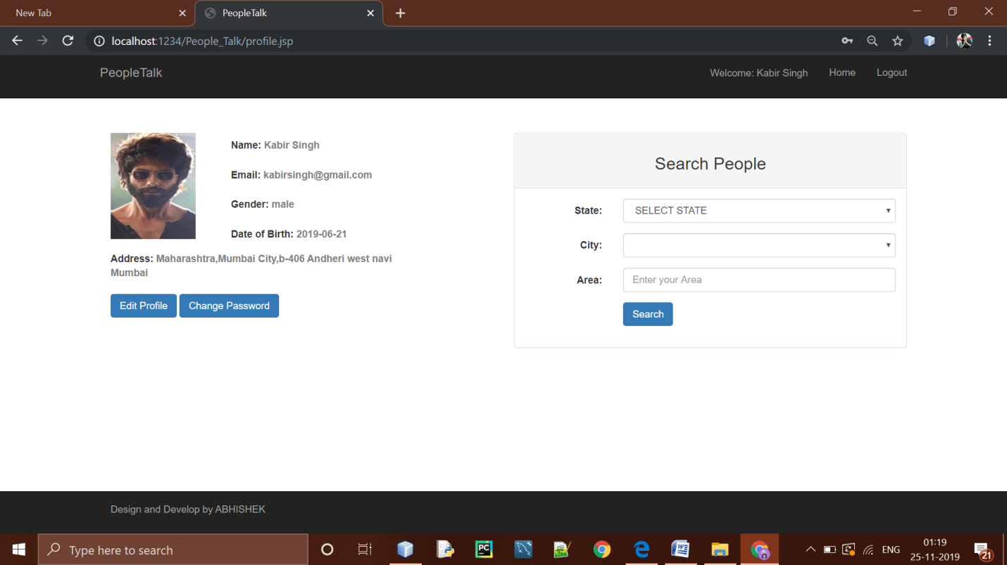Above is the third module which is the user’s profile in which a user can see his/her registered information and this module consists of the three parts edit profile, Change password and search people.

If a user do no uploads their profile picture then a default picture will be applied as their profile picture .

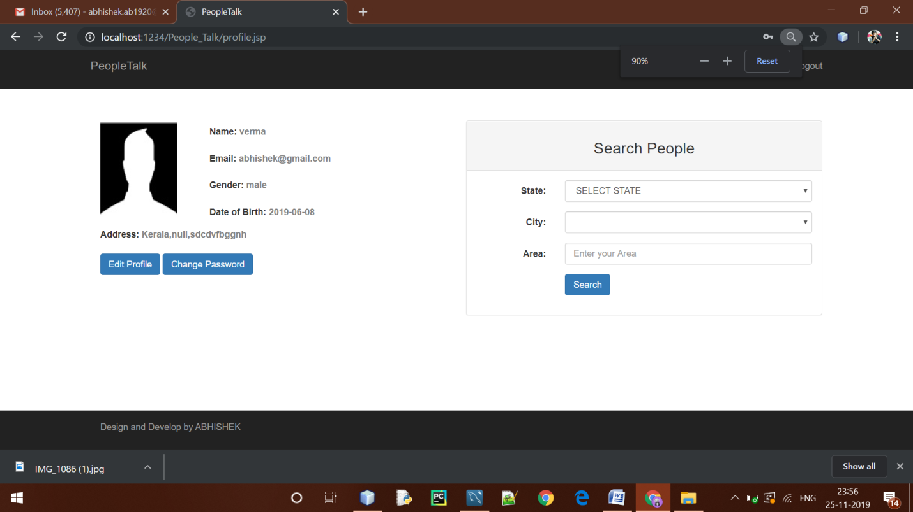

**MODULE 3nd : (EDIT PROFILE AND CHANGE PASSWORD)**

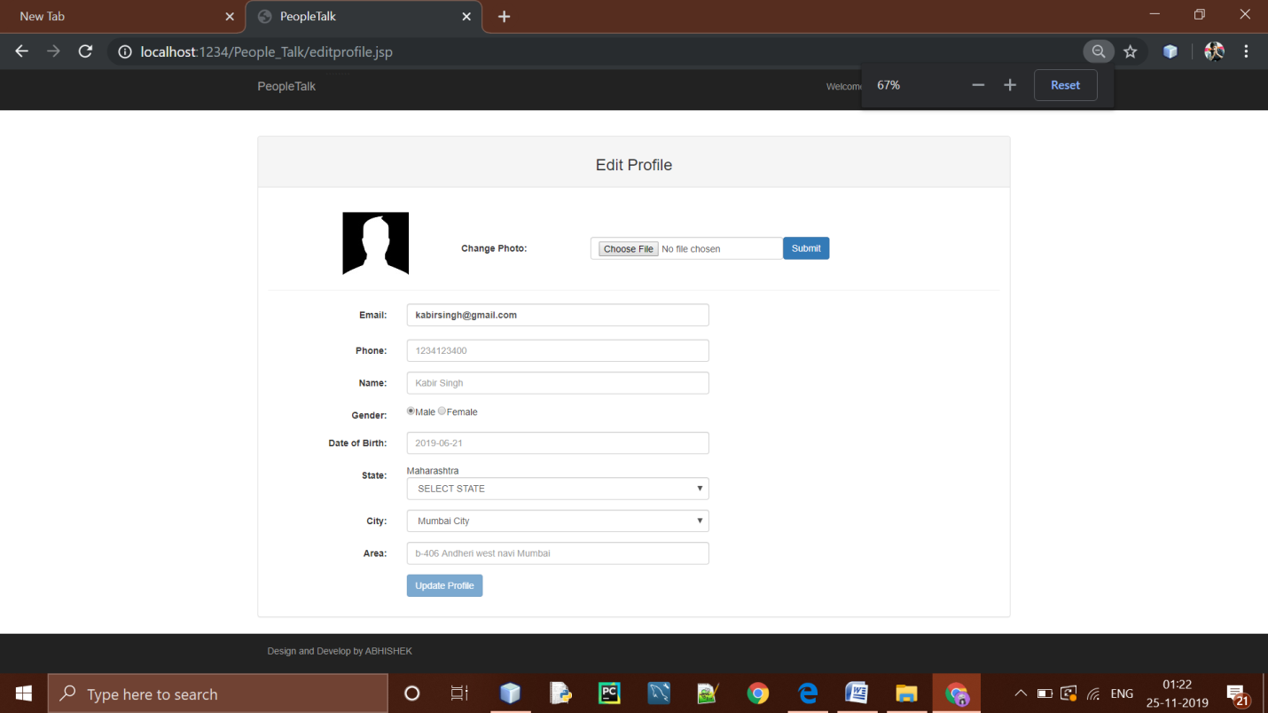

In this module, a user can edit his/her profile details just by entering the details that needs to be updated, and from here a user can also change their profile picture, a user will not able to change their mail ID.

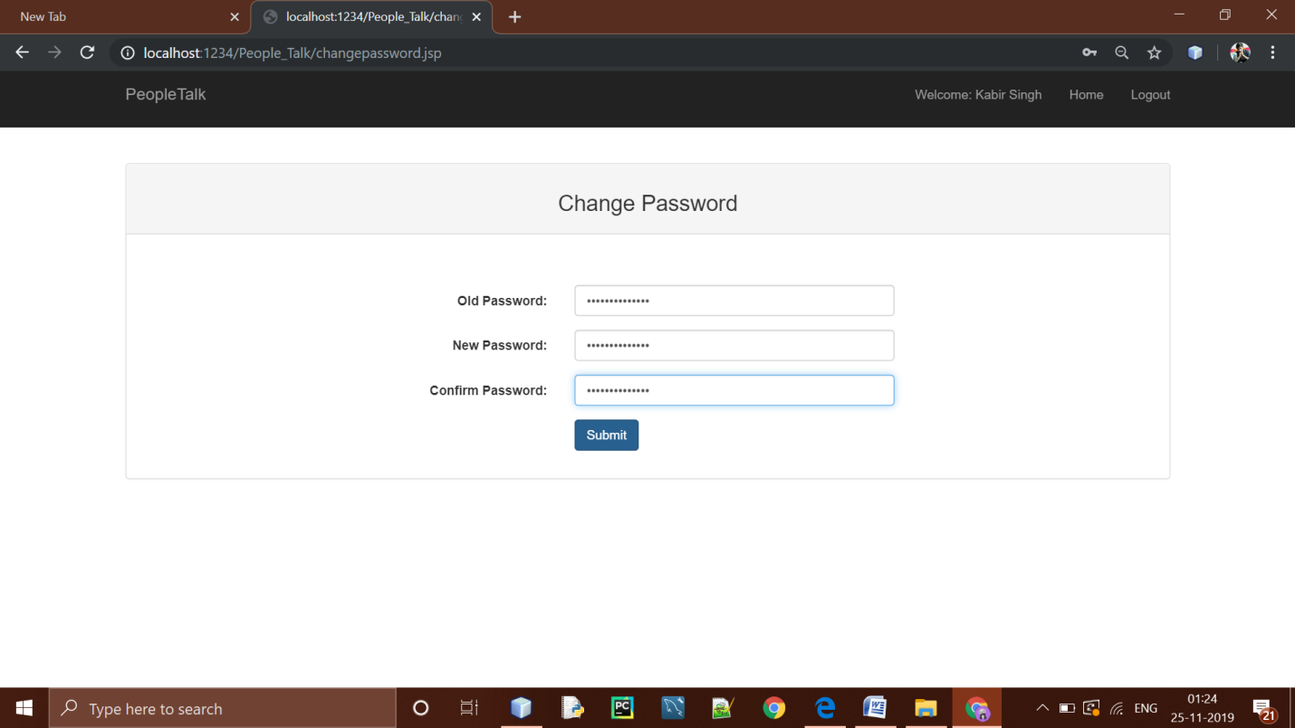

From here a user can change the password just by entering their old password and new password.

**MODULE 4th: (SEARCH PEOPLE)**

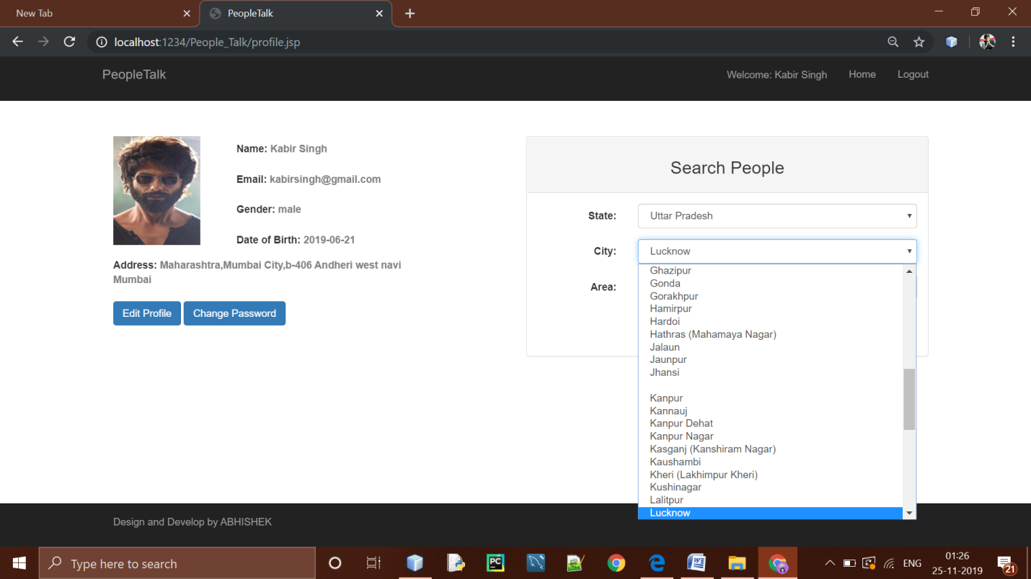

In this module a user can search the other people just by entering the state ,city and area where as area is optional after that click on search button.

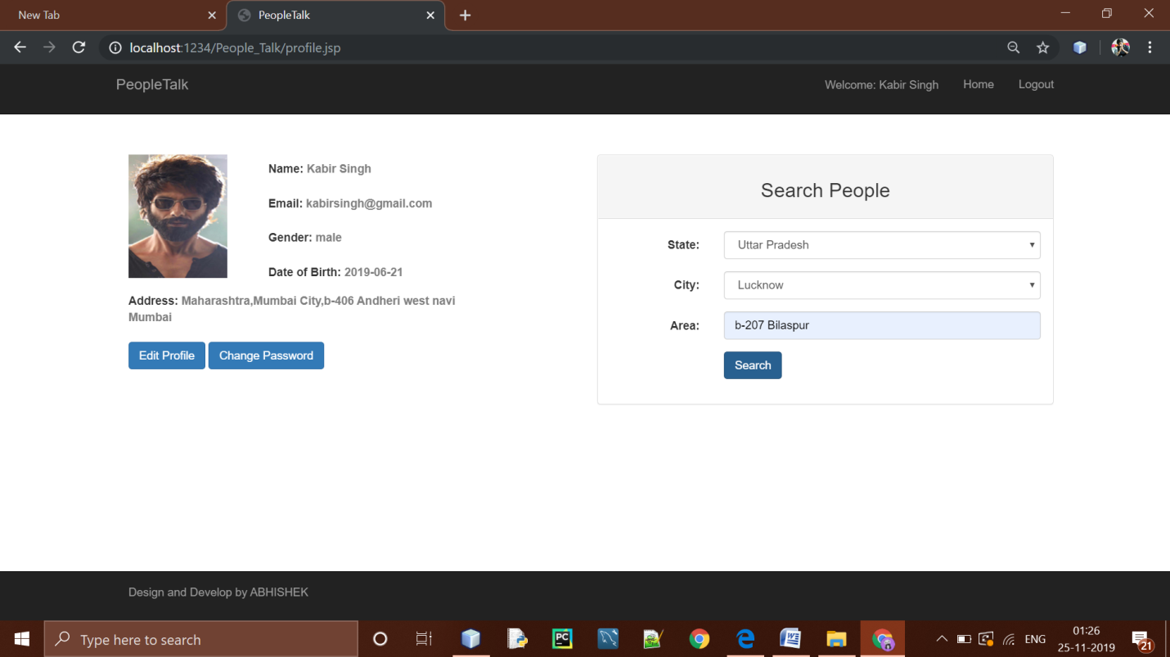

On clicking on the search button a user reach to the talk people module i.e a user get people based upon the state and city.**MODULE 5th: (TALK PEOPLE)**

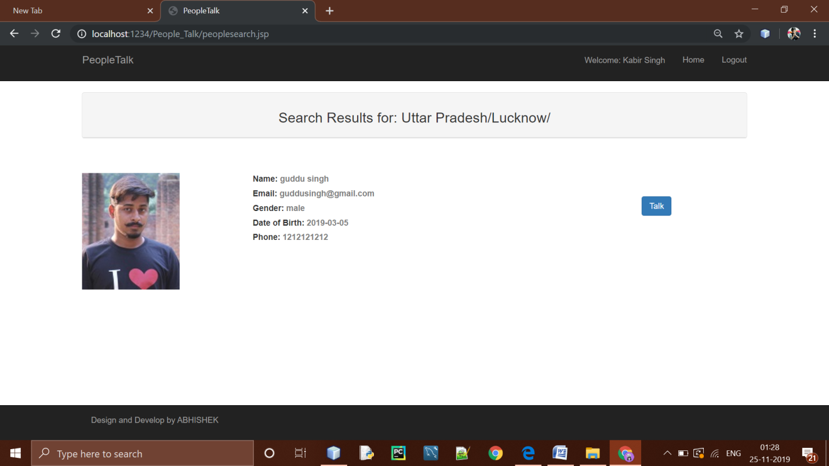

In this module a user can talk with other people based upon his/her interest just by clicking on the talk button.

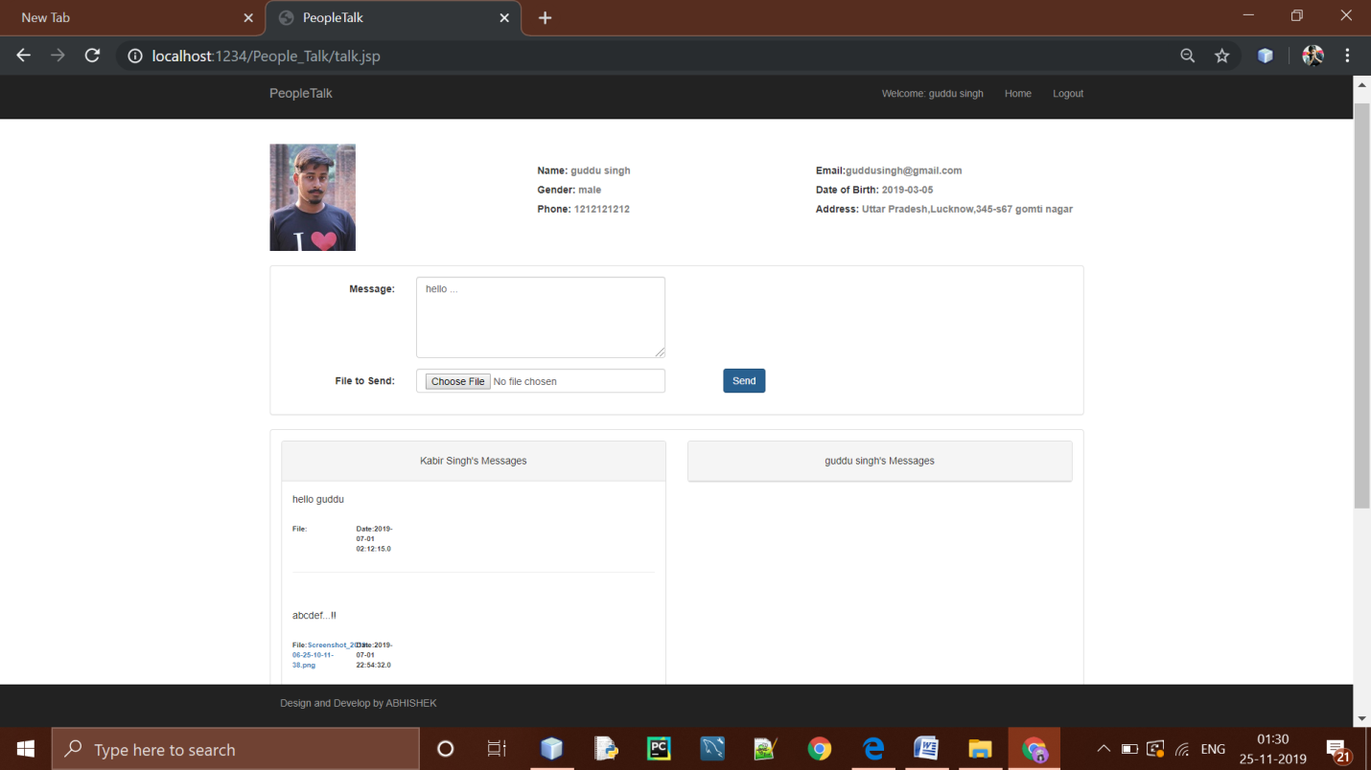

After clicking on the talk button a user will reach to the message sending receiving page from their a user can send the message to the selected people and receive message from that people, a menu is present in this page where all the communication between them would be shown.

ag

ah

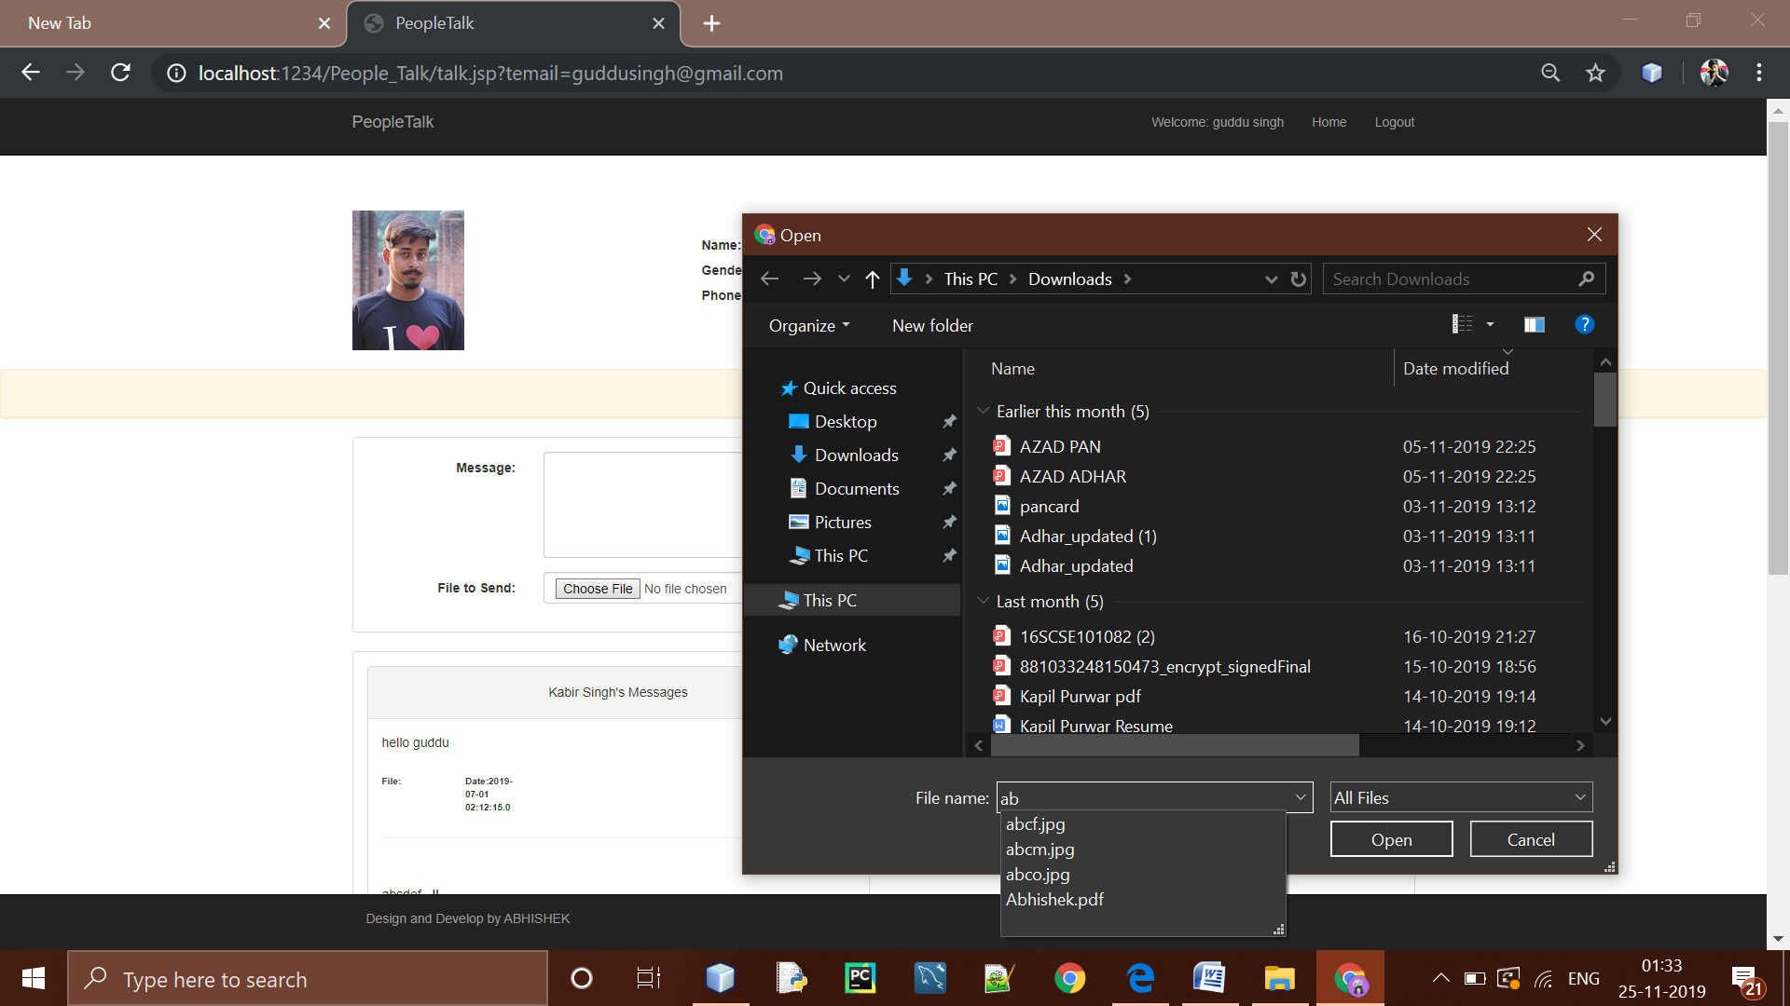

A user can also send the files to the other people just by clicking on the choose file.

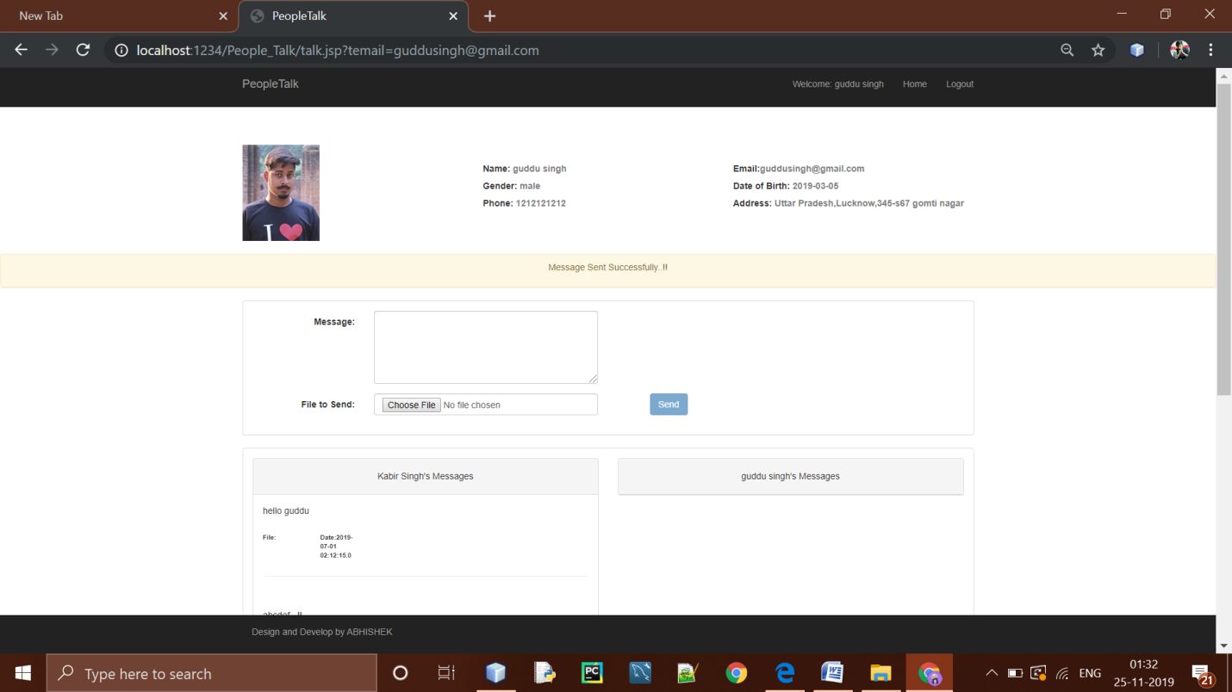

Message will be send to the other person only after clicking on the send button.

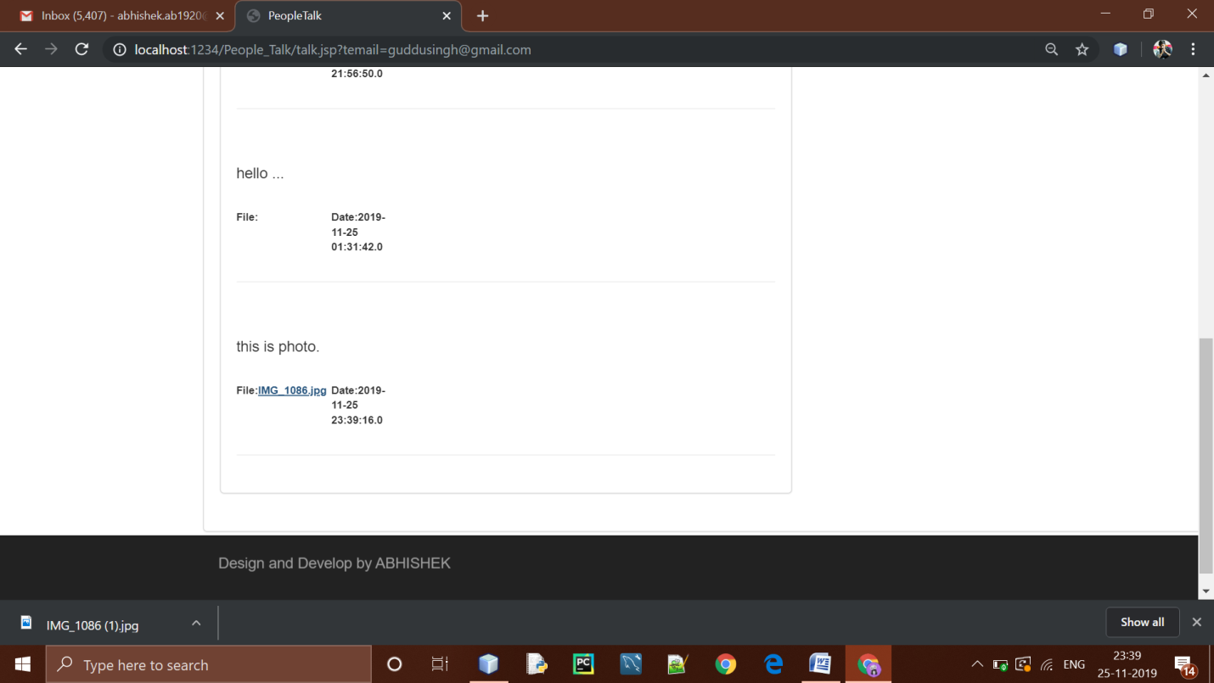

A user can download the files from the conversation message box just by clicking on it, the file will get download by its original name and extension.

**DATABASE: (TABLE 1ST PEOPLEMSG)**

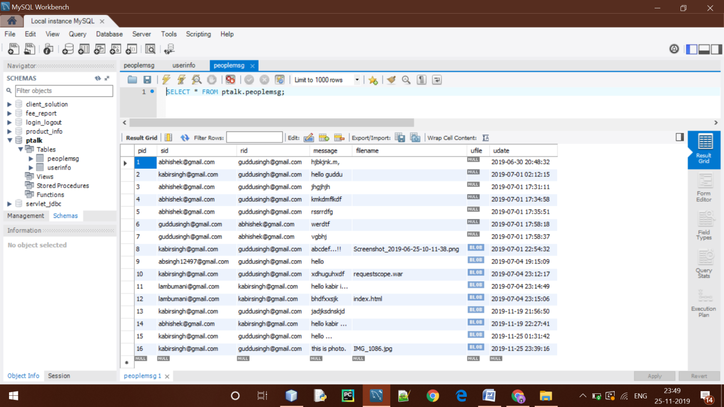This is the people Message table and name of this table is peoplemsg, in this table all the messages between two people is stored along with the files and dates time of the the messages.

**DATABASE: (TABLE 2nd USERINFO)**

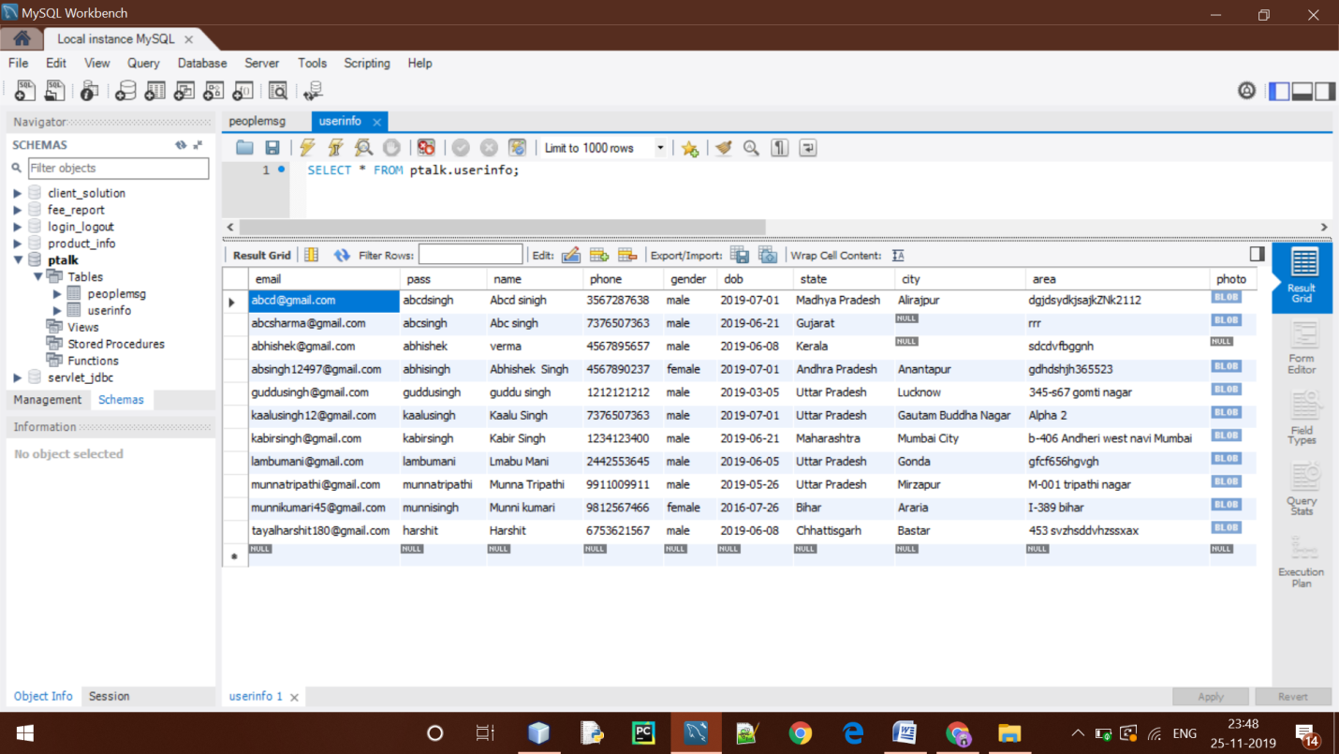

This is the user information table , in this all the registered information of a user is stored and in authentication this table is used and this table also contains the profile picture of the particular user.